Included is the game files to launch on all major platforms,

Windows, Linux, MacOS and Web.

While all platform types should work, we only tested and verified the Windows execution.

**To run windows**

1. export the project folder zip onto your local machine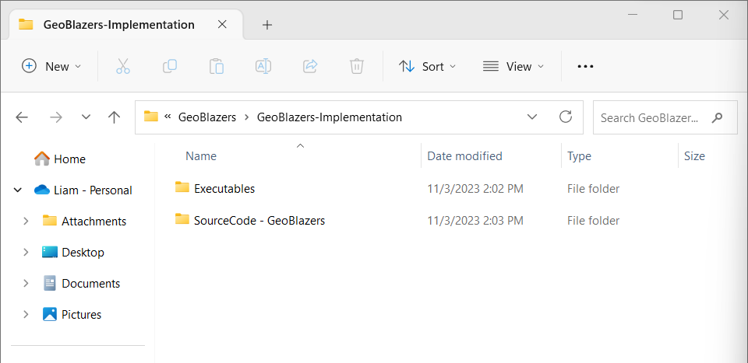
2. Open the GeoBlazers folder, and navigate to GeoBlazers-Executables. The remaining files and folders are the development code.
3. Navigate to the windows_exe folder
4. Finally, double click the Application file
5. If this doesn’t work, please try running as administrator.
6. Enjoy :)

**For any issues running the game, please reach out to me at 154477v@acadiau.ca**